**SSL/TLS Certificate**

1. **SSL/Certificate for Weblogic Console:**

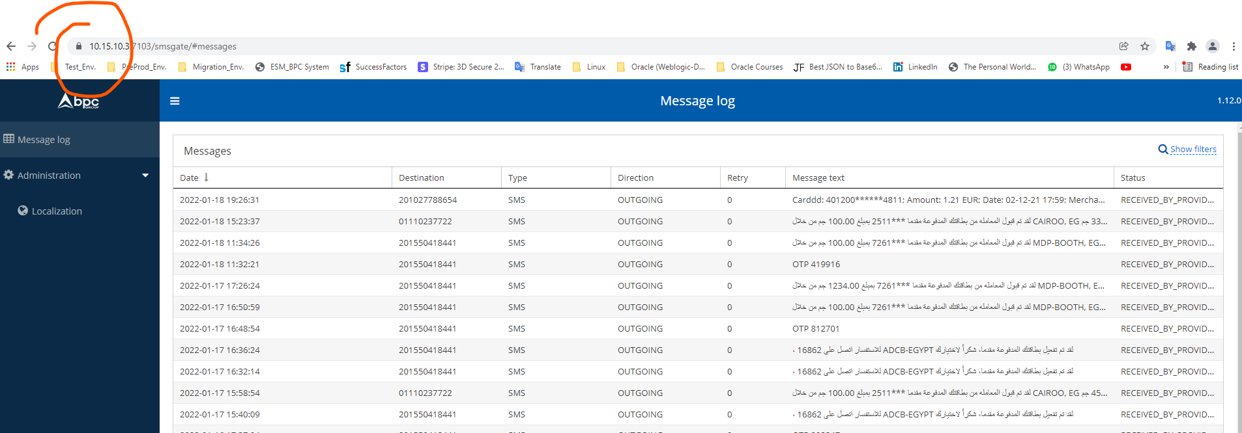

**Keystore Software**

**Genrate ssl certificate for test env.:**

**1-right click > then click “generate key pair”:**

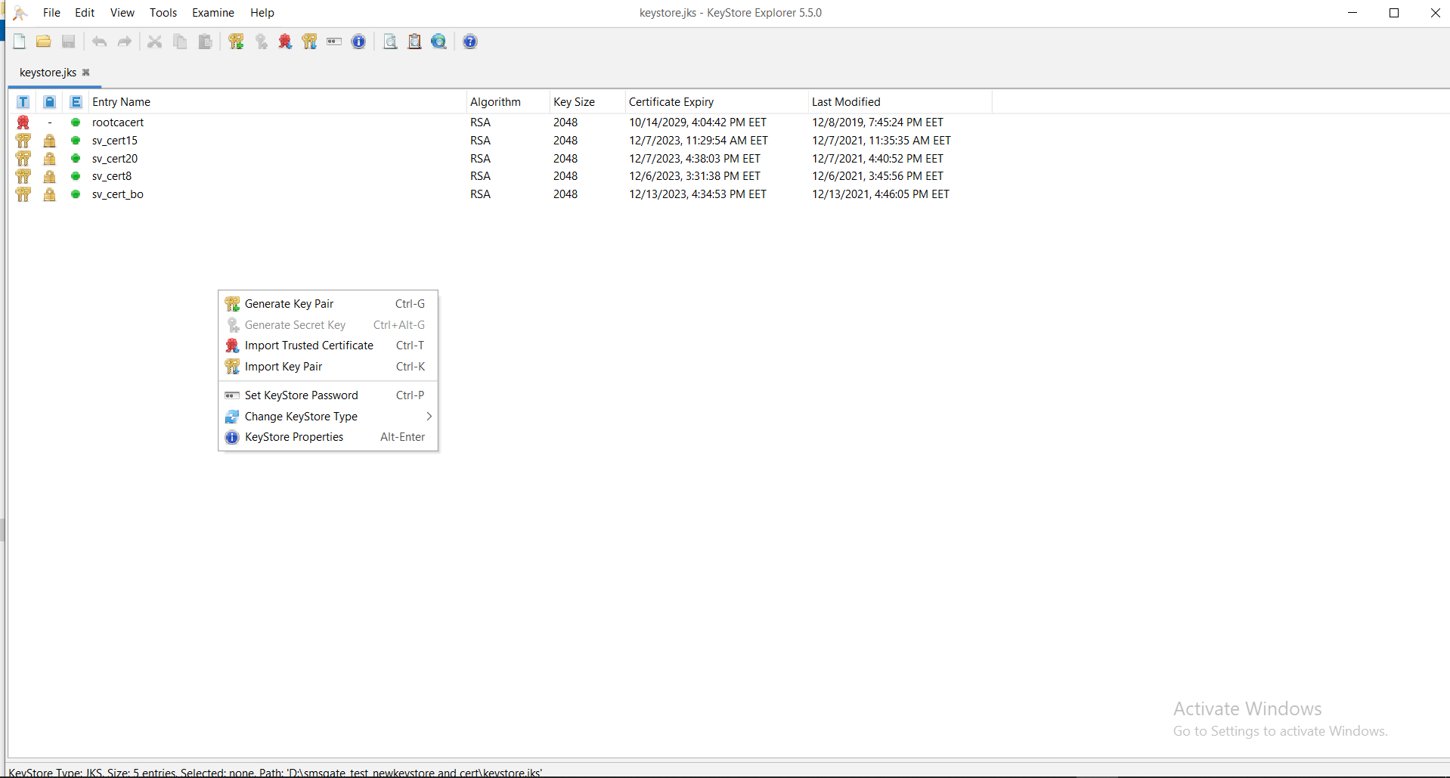

**2-**

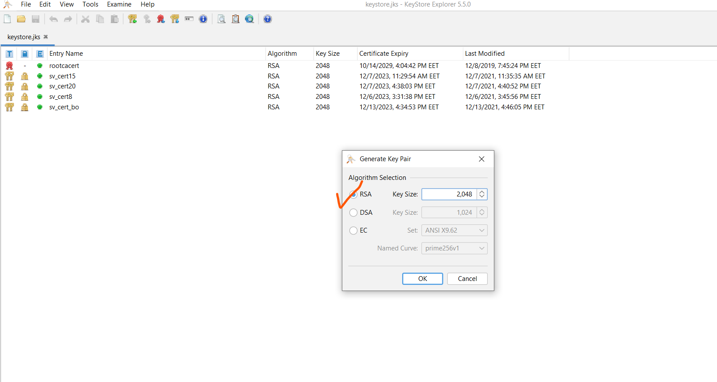

**3-**

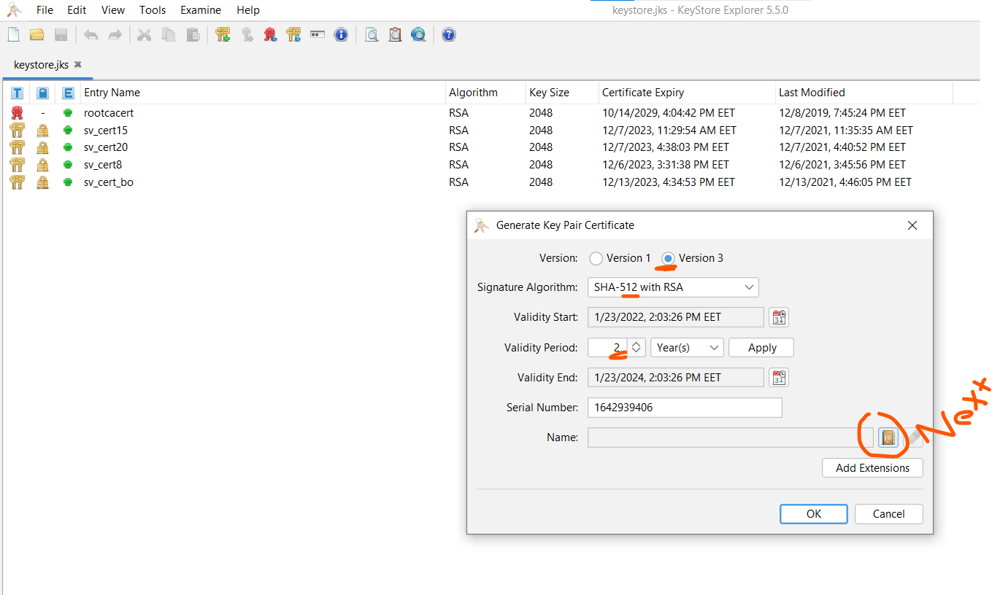

**4-**

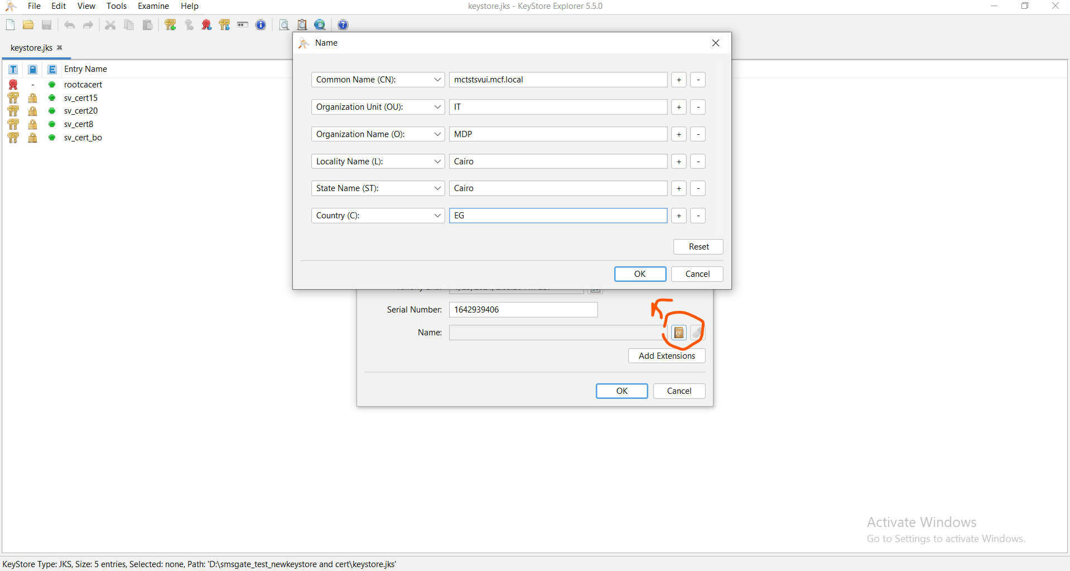

**5-**

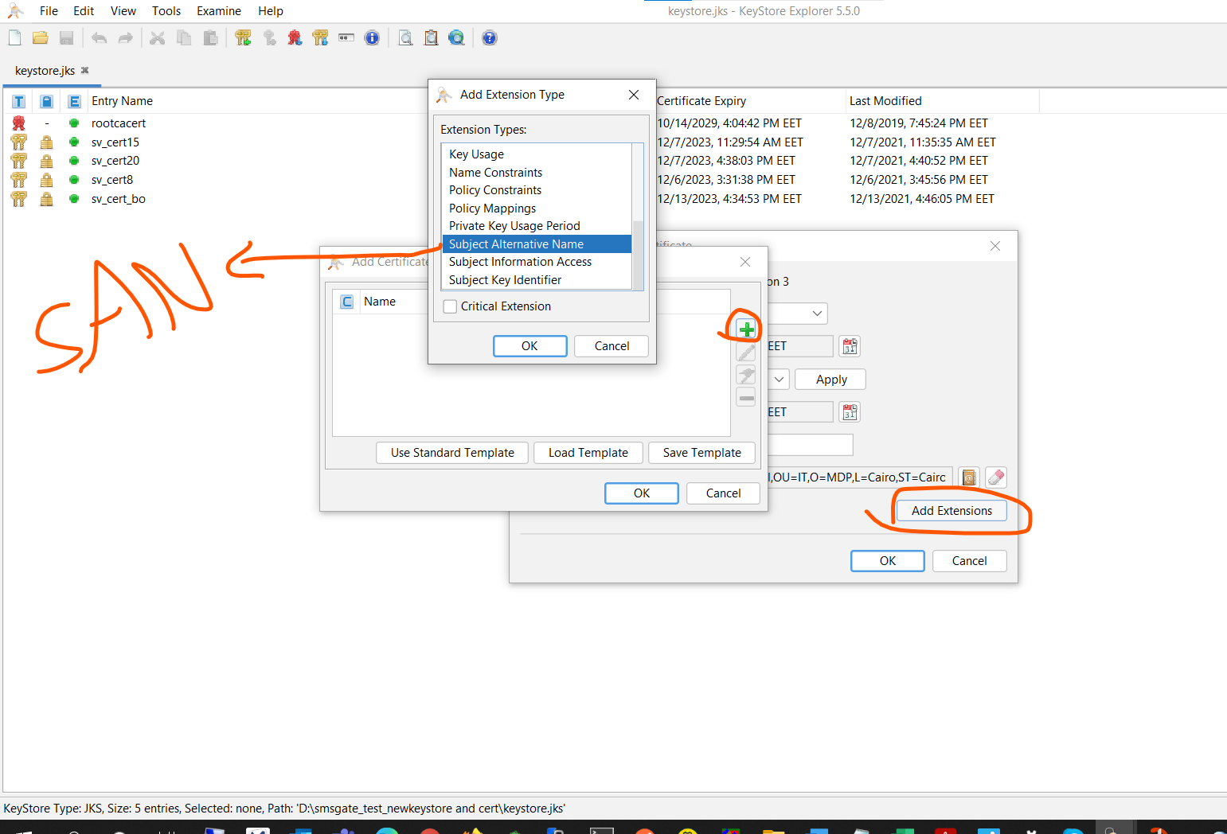

**6-**

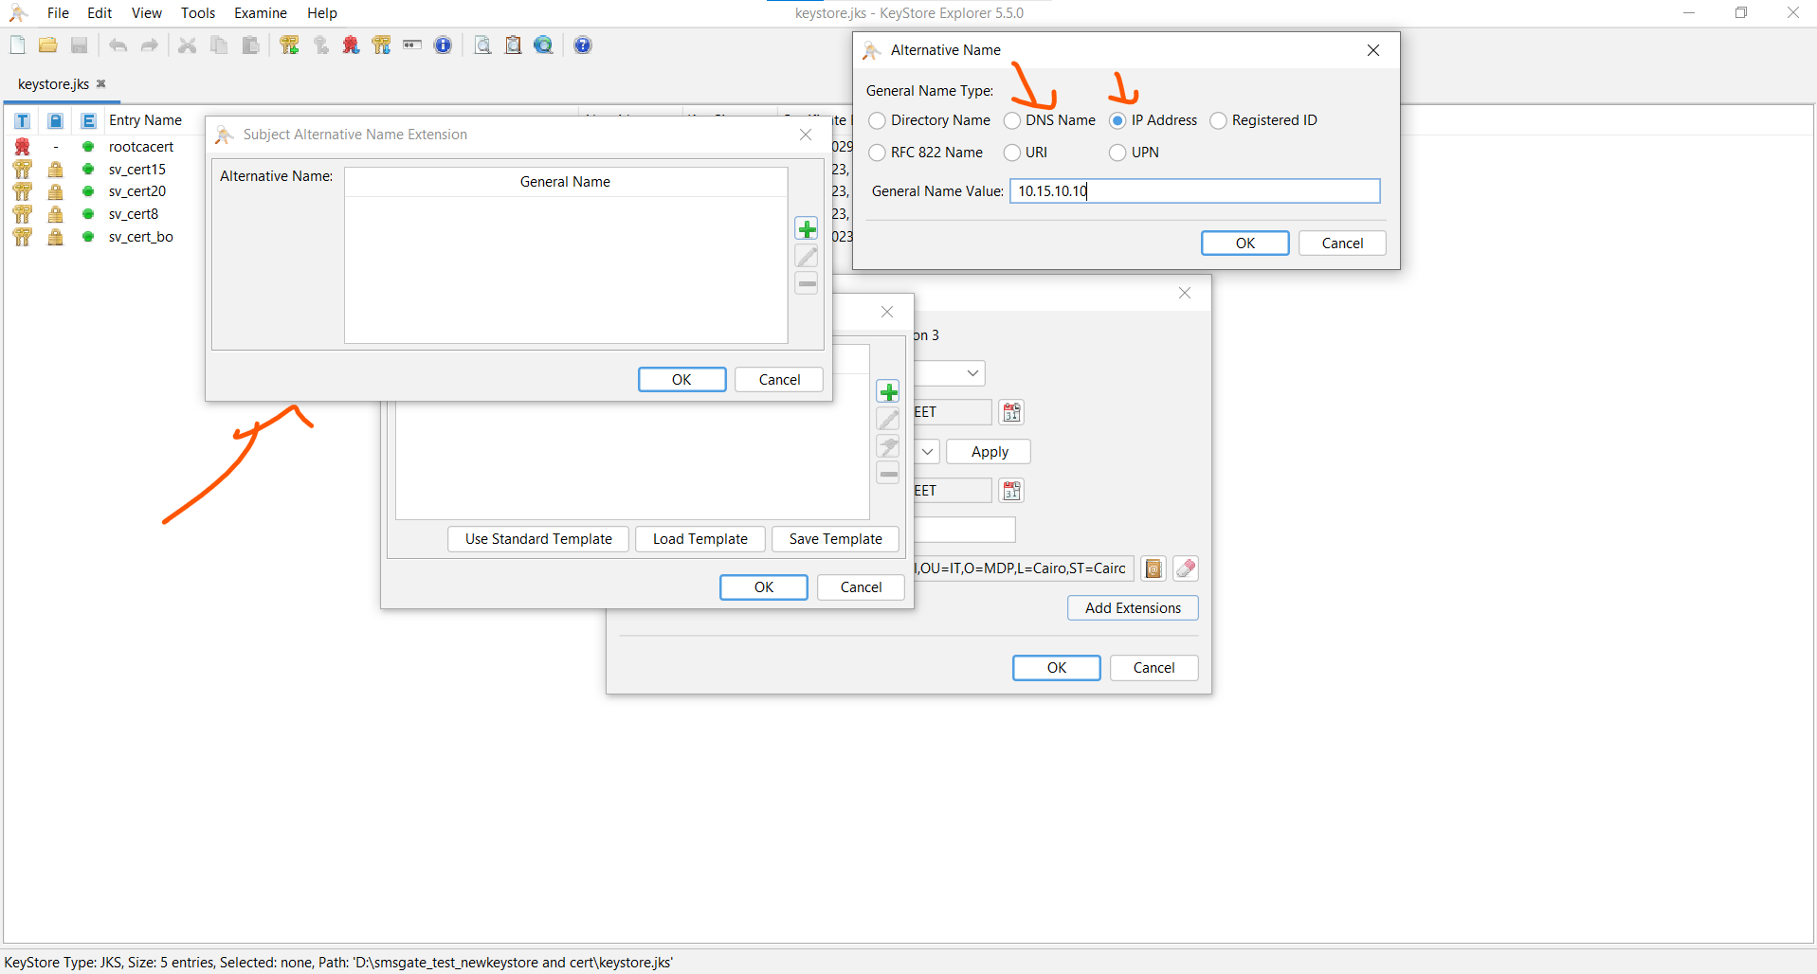

**7-**

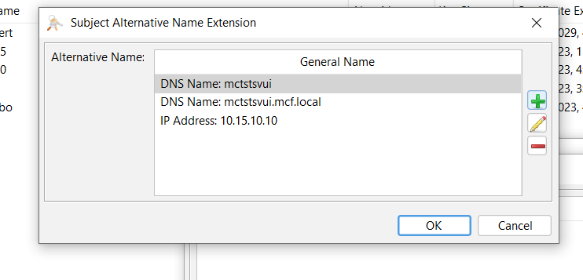

**8-**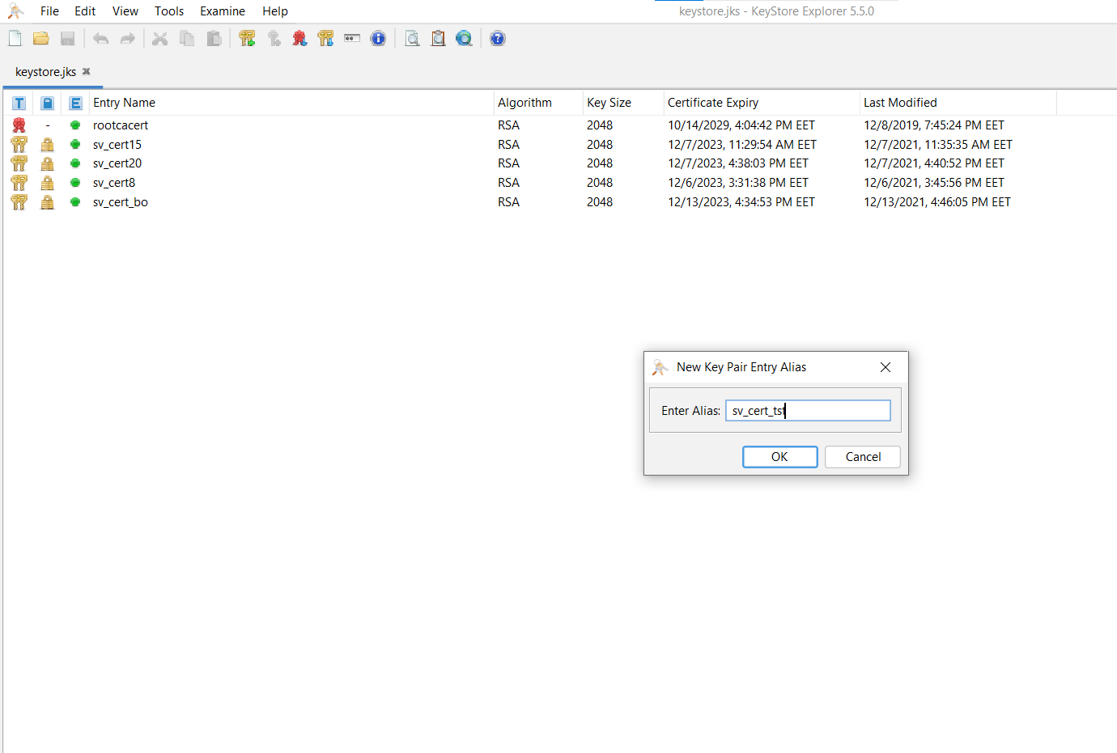

**9-**

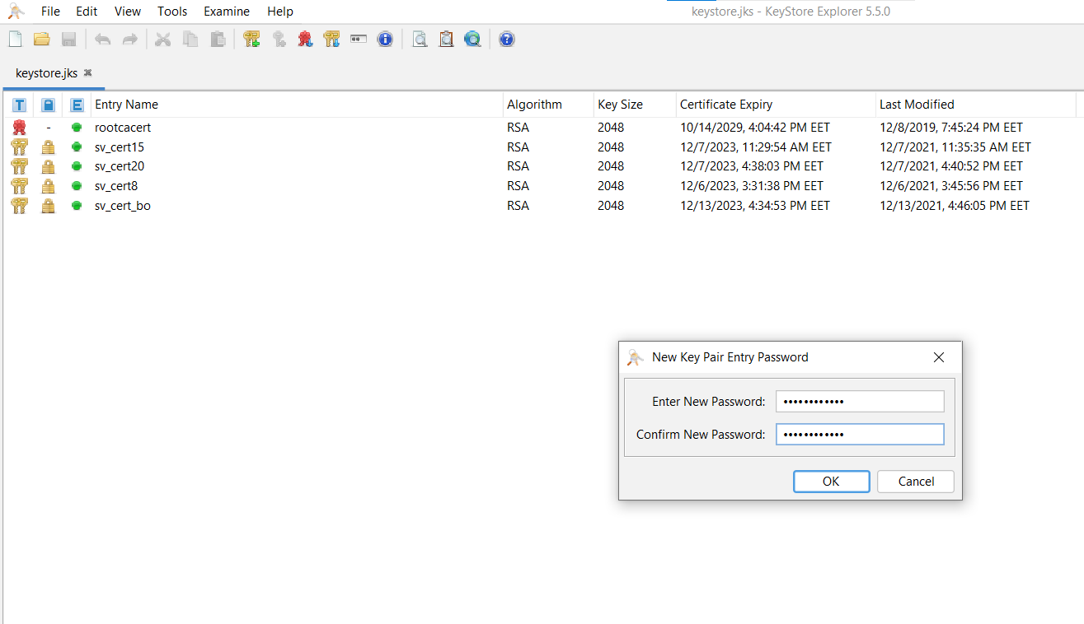

**10-**

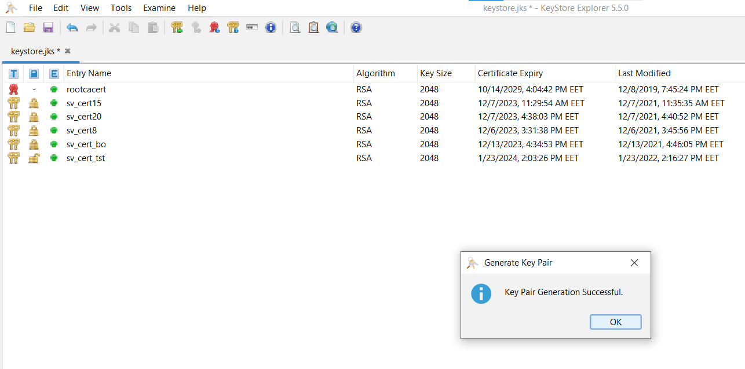

**11-then you can see it now in open lock > right click on it and click “generate CSR”:**

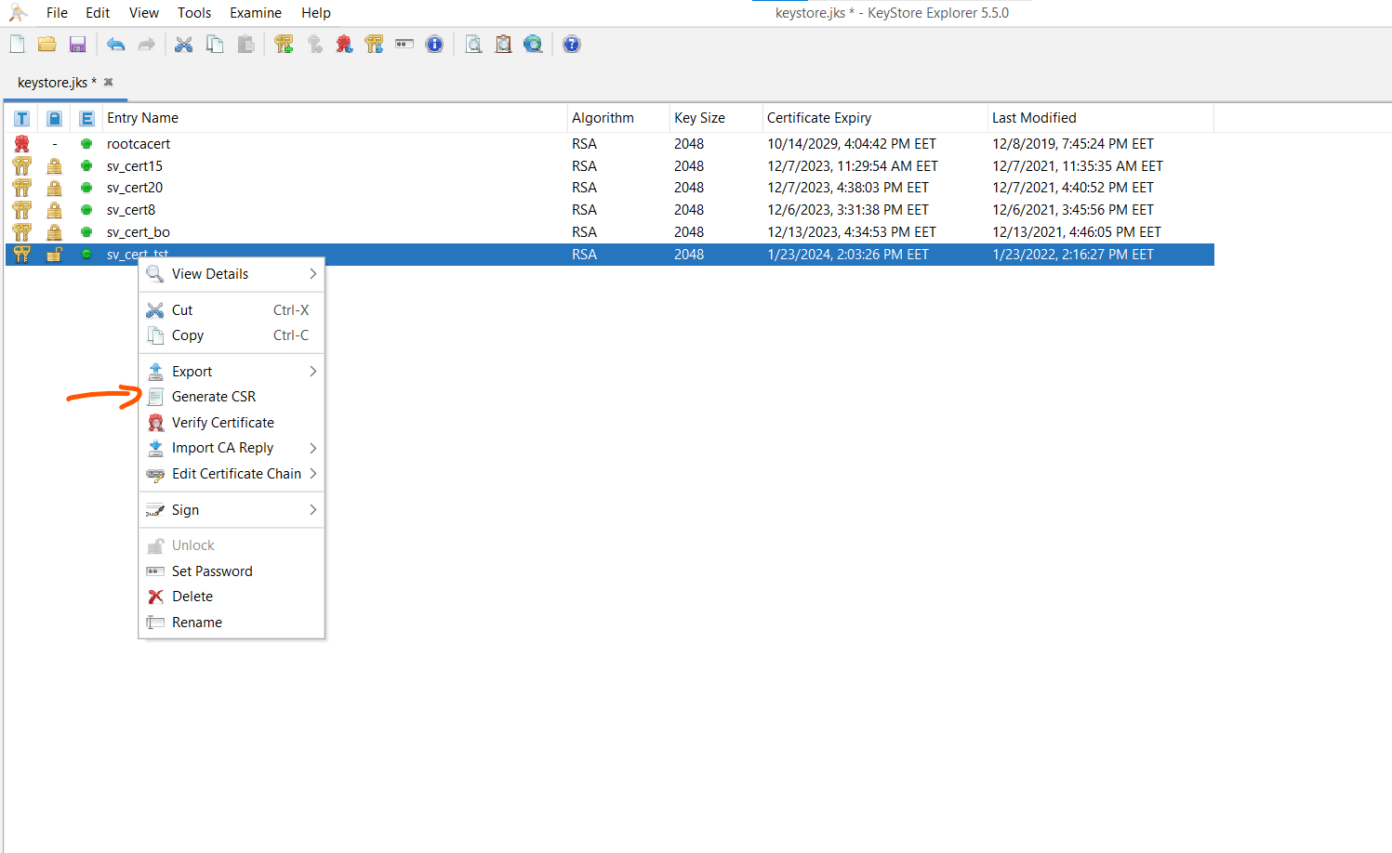

**12-**

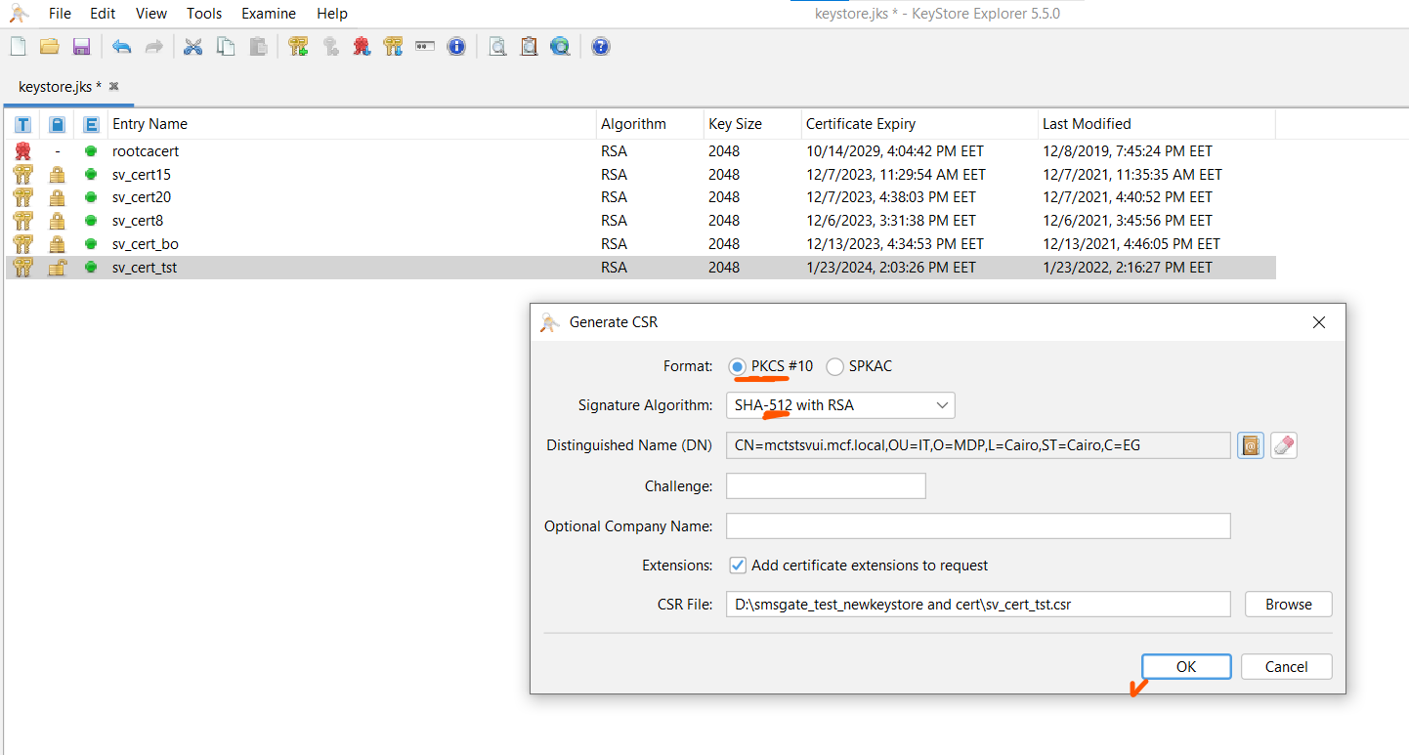

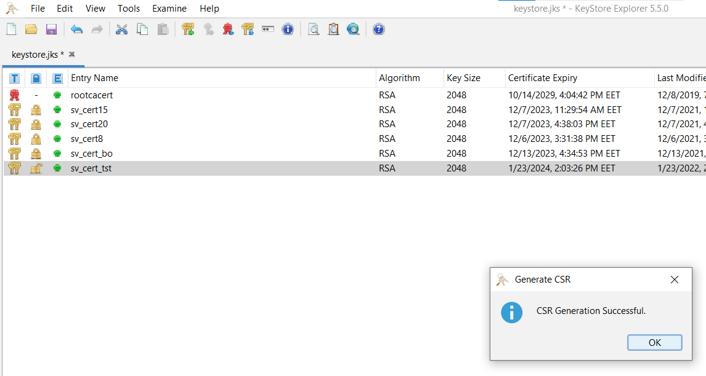

**13-send it to system admin to sign it from our local domain “from active directorey”:**

**System admin should copy the content of (.CSR)file into “saved request”**

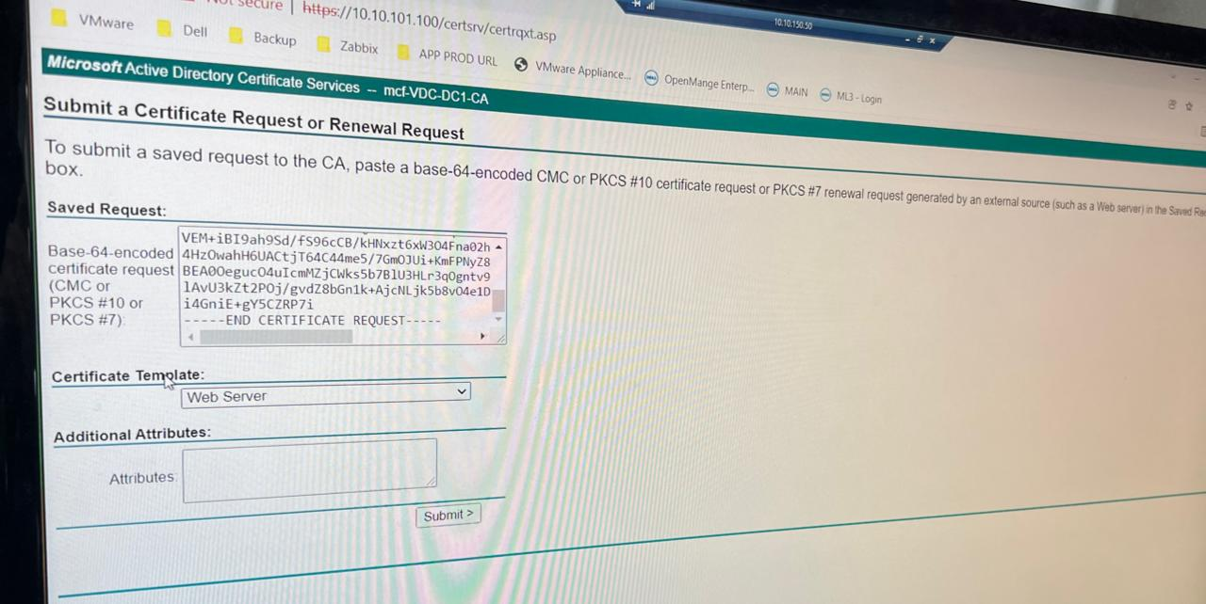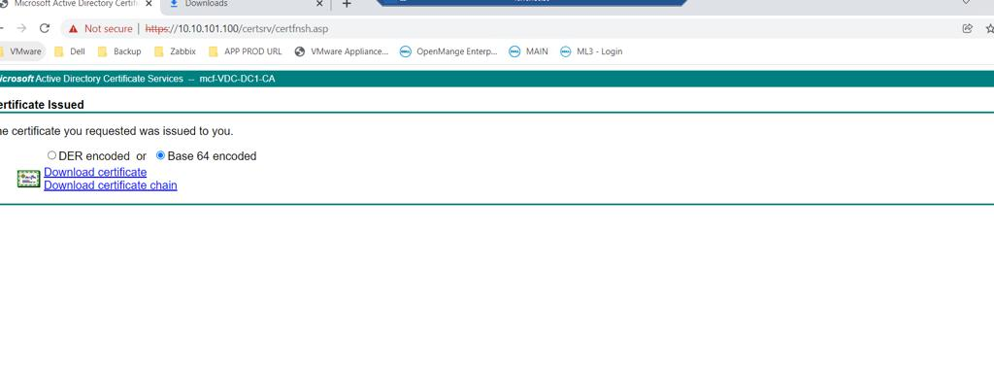

**14-import .p7p cert**

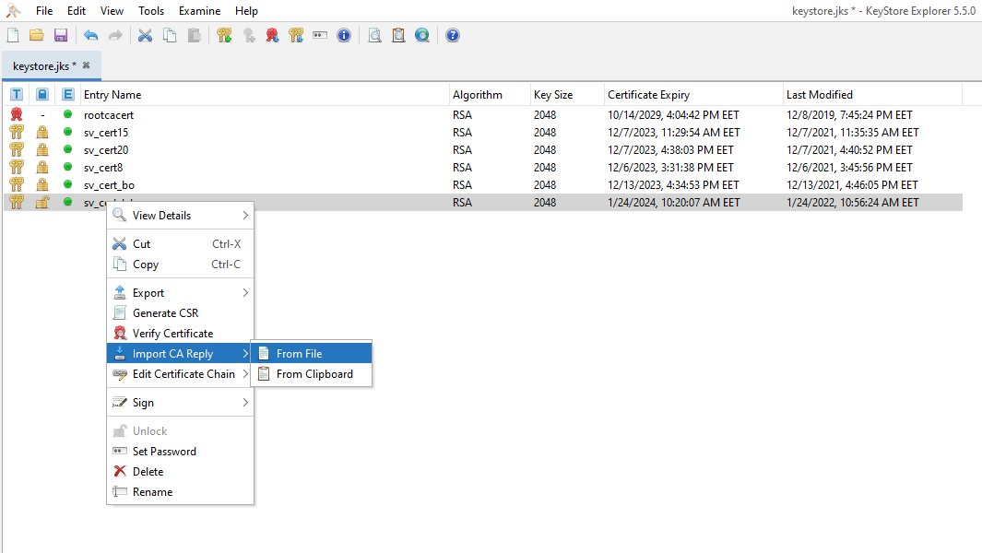

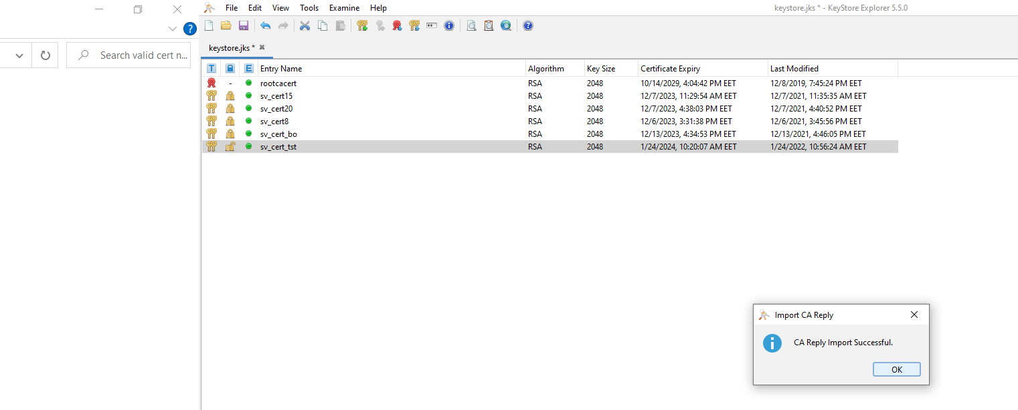

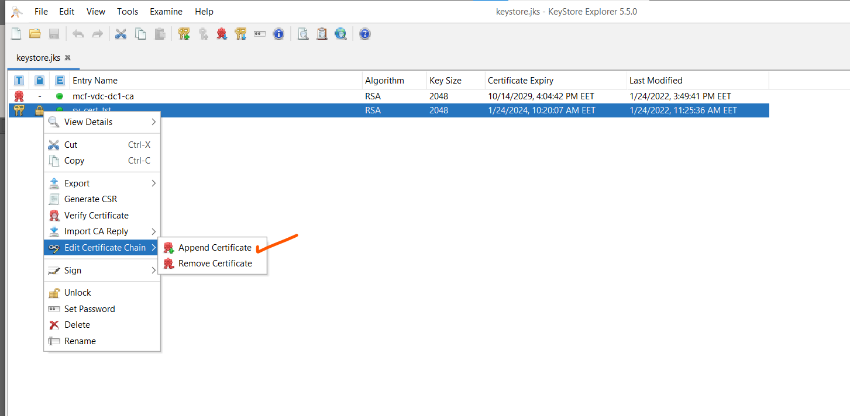

**Then it will be locked**

**You should import the root certificate with the keypairs locked:**

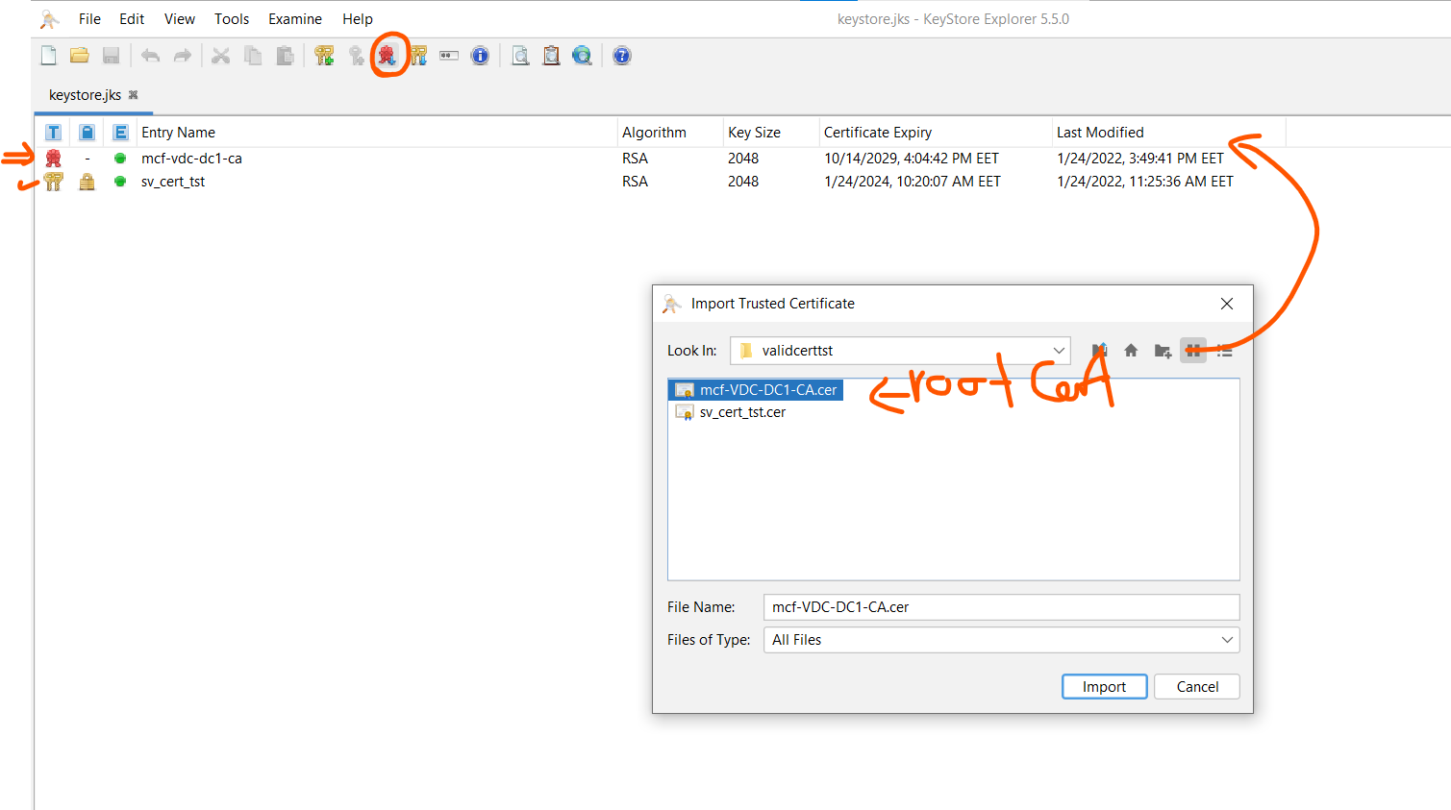

**Weblogic Side**

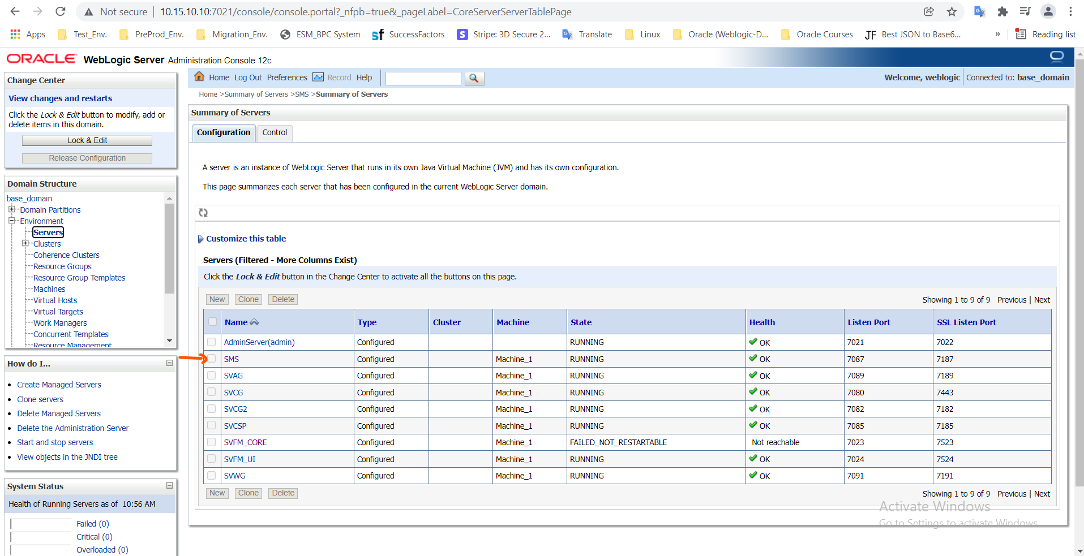

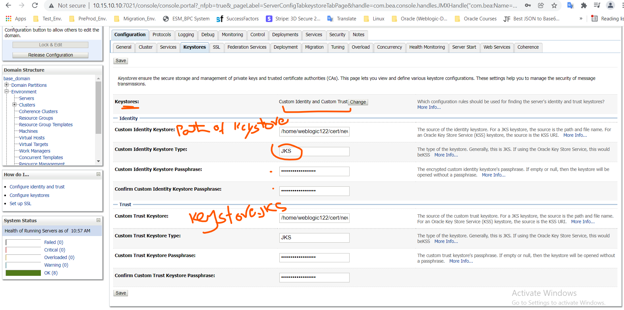

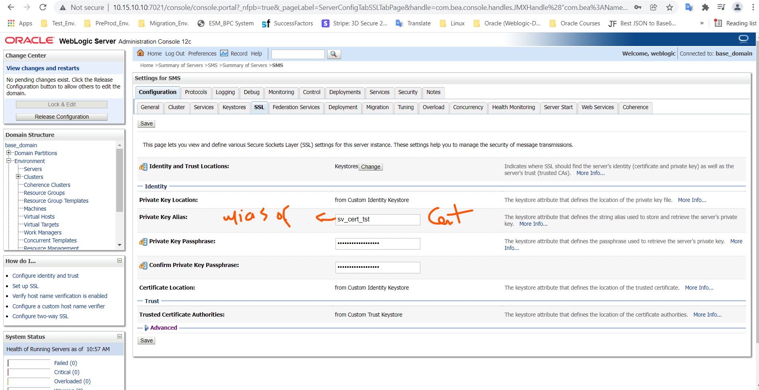

**Then you should restart**

1. **Ssl**
2. **The managed server**
3. **Deployments**

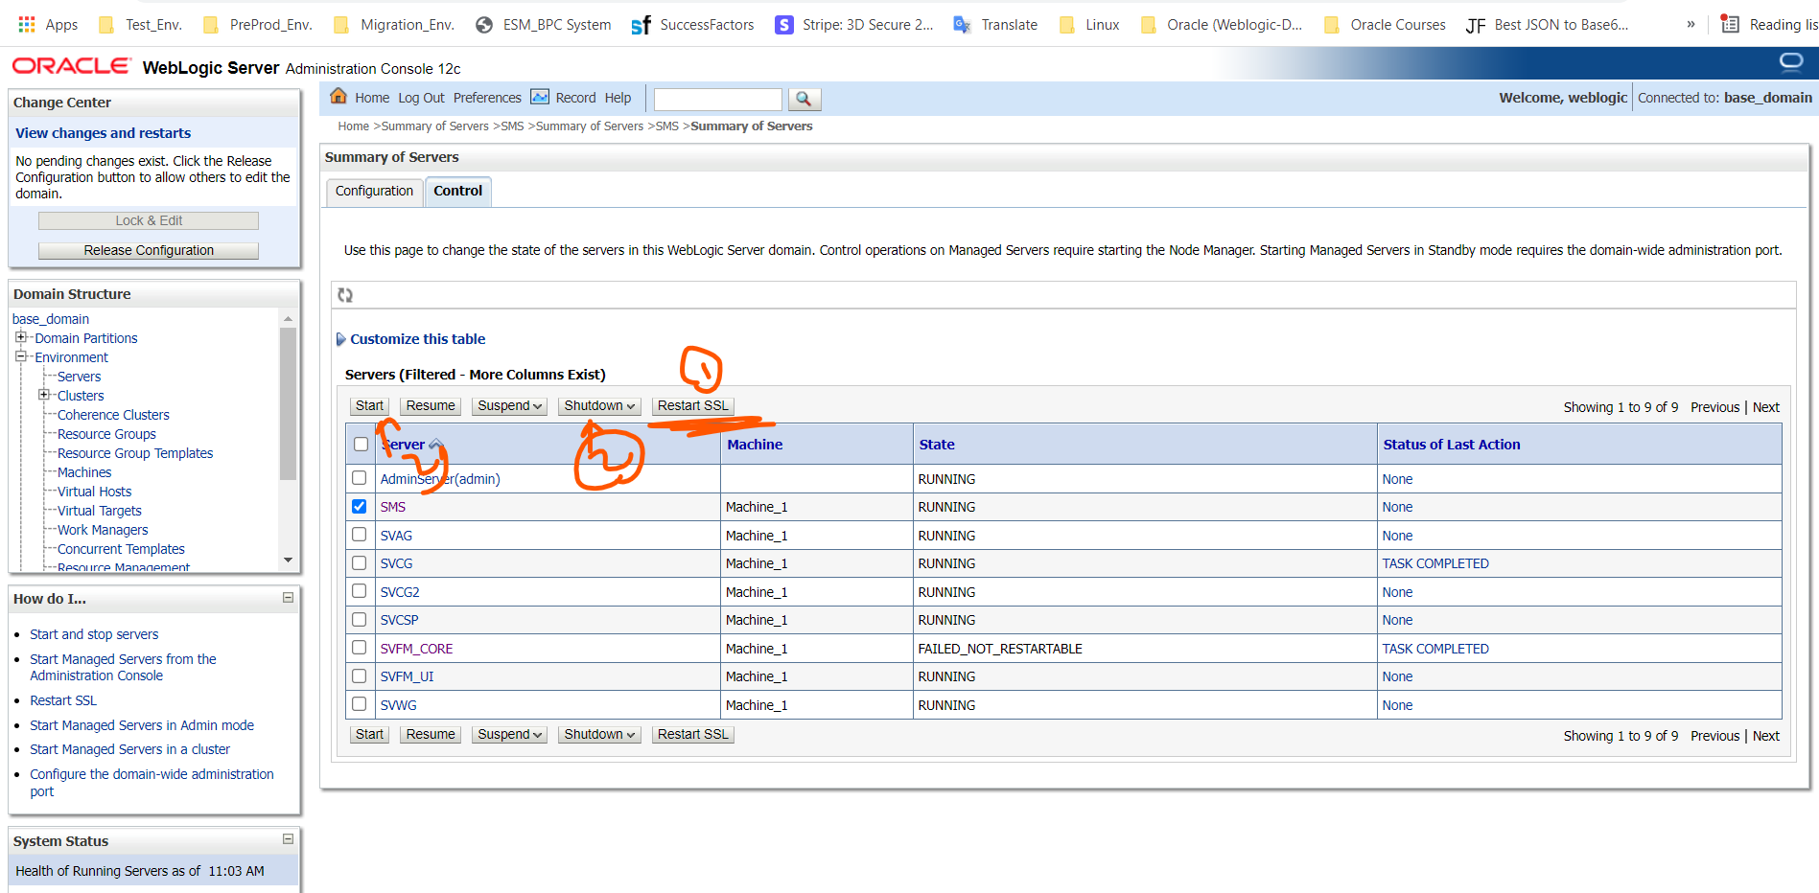

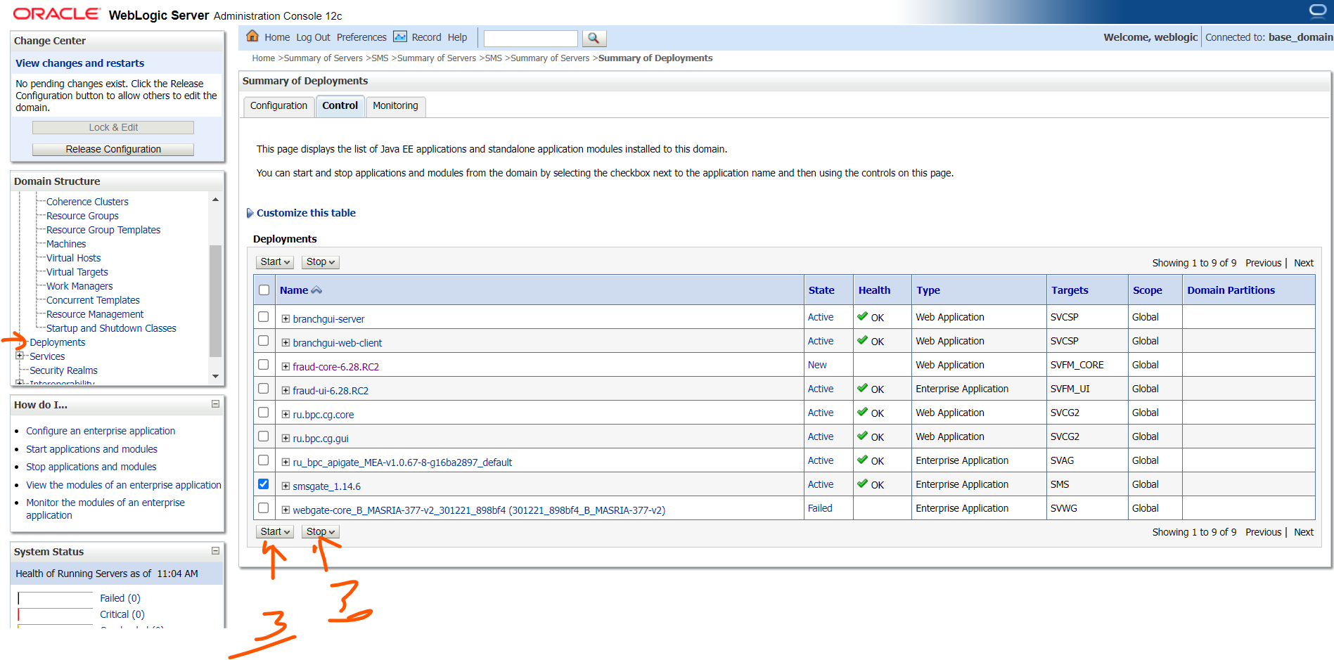

**2-For the OS and Weblogic TrustKeystore “use to call another server as a web service”**

**“ACS send OTP to SMSGATE”:**

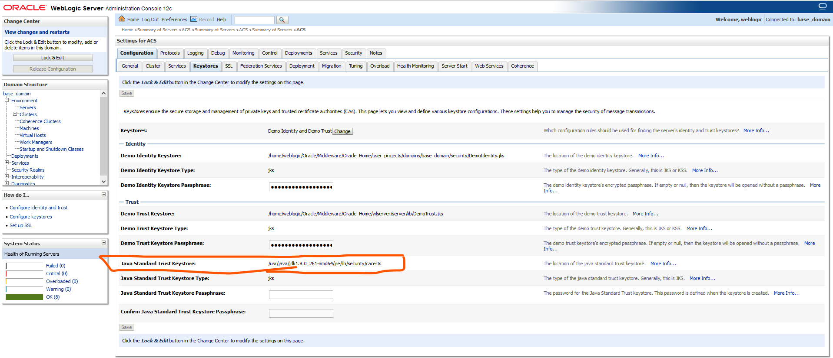

**Java keystore Path:**

**/usr/java/latest/jre/lib/security/cacerts**

**Default Java keystore password:**

**Changeit**

* **We must import theSMSGATE_RootCertificate to java keystore**

**keytool -import -trustcacerts -keystore /usr/java/latest/jre/lib/security/cacerts**

**-storepass changeit -noprompt -alias tstrootcer-2022 -file /home/weblogic/acscertificate/tstsms/roottstcer.cer**

**>>>>>>>>>>>>>>>>>>>>>>>>>>>>>>>>to avoid the error <<<<<<<<<<<<<<<<<<<<<<<<<<<<<<<<<<<<<<**

**“**Caused by: javax.net.ssl.SSLHandshakeException: SSLHandshakeException invoking <https://10.15.10.3:7103/smsgate/ws/gate?wsdl:> PKIX path building failed: sun.security.provider.certpath.SunCertPathBuilderException: unable to find valid certification path to requested target**”**

* **Not sure if we should import thechain_certificate .cer in java keystore**

**keytool -import -trustcacerts -keystore /usr/java/latest/jre/lib/security/cacerts**

**-storepass changeit -noprompt -alias mycert -file /home/weblogic/Amr_Ahmed/chaincertificate.cer**

* **we should append theSMSGATE_RootCertificate to tls-ca-bundle.pem**

**cat "Root_certificate.crt" >> /etc/pki/tls/certs/ca-bundle.crt**

**cat "Root_certificate.crt" >> /etc/pki/ca-trust/extracted/pem/tls-ca-bundle.pem**

**>>>>>>>>>>>>>>>>>>>>>>>>>>>>>>>>to avoid the error <<<<<<<<<<<<<<<<<<<<<<<<<<<<<<<<<<<<<<**

When we curl -iv on https:smsgate>>>>>>>>>>>And get error unknown issuer

curl: (60) SSL certificate problem: unable to get local issuer certificate